# Eventer App - Python Web Basics Exam

*Create a user-friendly* **eventer_app** *that empowers users to create and manage events. The app features an event catalog for easy exploration. Users can register using the create profile form and gain the flexibility to effortlessly create, edit, and delete their own event listings whenever they want.*

## Skeleton

All the necessary **HTML pages**, **images**, and **CSS** files for the project are included for your convenience.

## Database

**Two models** will be required for the task at hand.

* **ProfileModel**
  + **First Name**
    - CharField, **required**
    - It should consist of a **maximum of 20 characters**
    - The first name can consist **only of letters.** Otherwise, raise a **ValidationError** with the message: **"The name should contain only letters!"**
  + **Last Name**
    - CharField, **required**
    - It should have at least **4 characters** and **maximum -** **30 characters**
  + **Email**
    - EmailField, **required**
    - It should consist of a **maximum of 45 characters**
  + **Profile Picture**
    - URLfield, **optional**
  + **Password**
    - CharField, **required**
    - It should have at least **5 characters** and **maximum -** **20 characters**
    - If the password does not contain at **least one digit**, an exception of type **ValidationError** should be raised, accompanied by the message: **"The password must contain at least 1 digit!"**
* **EventModel**
  + **Event Name**
    - CharField, **required**
    - It should have at least **2 characters** and **maximum -** **30 characters**
  + **Category**
    - CharField, **required**
    - The choices are **"Sports"**, **"Festivals"**, **"Conferences"**, **"Performing Art"**, **"Concerts"**, **"Theme Party"** and **"Other"**
  + **Description**
    - TextField, **optional**
  + **Date**
    - DateField, **required**
    - To prevent users from selecting a date earlier than today (a date in the past) for his/her events, a **ValidationError** should be raised with the message: **"The date cannot be in the past!"**
  + **Event Image**
    - URLField, **required**

**Note: The validations will be evaluated exclusively on the user side and not on the admin side.**

## Routes

* <http://localhost:8000/> - home page
* [http://localhost:8000/dashboard/](http://localhost:8000/album) - dashboard page
* <http://localhost:8000/>create/ - create event page
* [http://localhost:8000/details/<id](http://localhost:8000/details/%3cid)>/ - event details page
* [http://localhost:8000/edit/<id](http://localhost:8000/edit/%3cid)>/ - edit event page
* [http://localhost:8000/delete/<id](http://localhost:8000/delete/%3cid)>/ - delete event page
* <http://localhost:8000/profile/create/> - create profile page
* <http://localhost:8000/profile/details/> - profile details page
* [http://localhost:8000/profile/edit/](http://localhost:8000/profile/details/) - edit profile page
* http://localhost:8000/profile/delete/ - delete profile page

## Pages

### Base Template

**Template file**: **"shared/base.html"**

The template serves as the fundamental structure for all the project's templates. It includes the project's metadata, **Navigation Bar section** and the **Footer section** that are utilized throughout the application.

### Home Page and Navigation Bar (10 pts)

**Template file**: **"shared/home-page.html"**

The **Home Page** should display the **Navigation Bar**, which includes relevant links depending on whether the user has created a profile or not. Additionally, it showcases a **Welcome Text**, an **image of party people**, and a **Footer section**.

The **Navigation Bar** consists of the following links:

* **"Eventer"** logo link, which directs to the **home page**
* **"Create Profile"** link, which directs to the **create profile page**
* **"Events"** link, which directs to the **dashboard page**
* **"Add Event"** link, which directs to the **create event page**
* **"Profile"** link, which directs to the **profile details page**

Please note that the **"Create Profile"** link on the **Navigation Bar** will **only be visible** if the user **has NOT created a profile yet**.

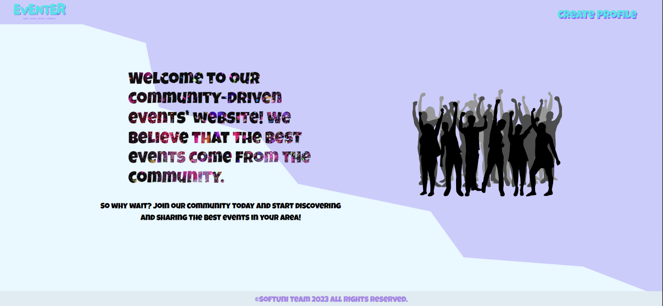

The visibility of the **"Events"**, **"Add Event"**, and **"Profile"** links on the **Navigation Bar** is limited to situations where the user **has an existing profile**.

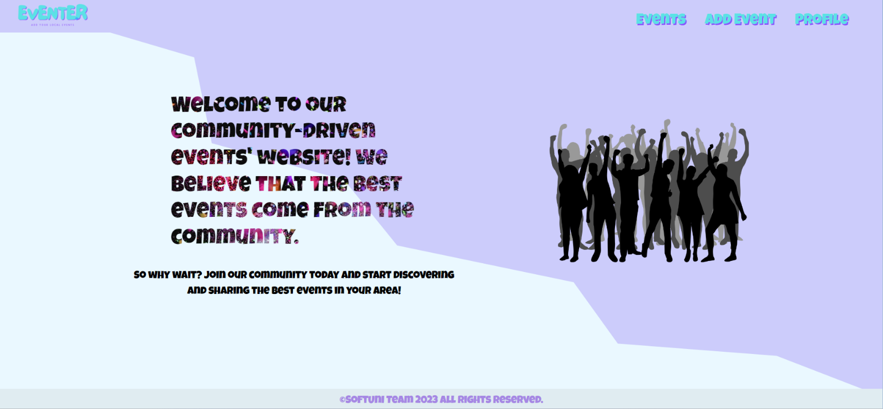

### Create Profile Page (10 pts)

**Template file**: **"profiles/profile-create.html"**

The **Create Profile Form** comprises the following:

* **"Email:"** field
* **"Profile Picture:"** field
* **"Password:"** field
* **"SUBMIT"** button

Clicking the **"SUBMIT"** button will lead you to the **dashboard page** if the profile is **successfully created**. Otherwise, the form will exhibit the **appropriate validation errors**.

* Note: Highly recommend finding a suitable widget that enables you to mask the password input using asterisk placeholders. However, please note that the visibility of the password, whether hidden or not, will not affect the evaluation or scoring of your exam. So, feel free to choose the approach that works best for you. The important factor is to ensure the functionality of the password input, rather than the visual presentation.

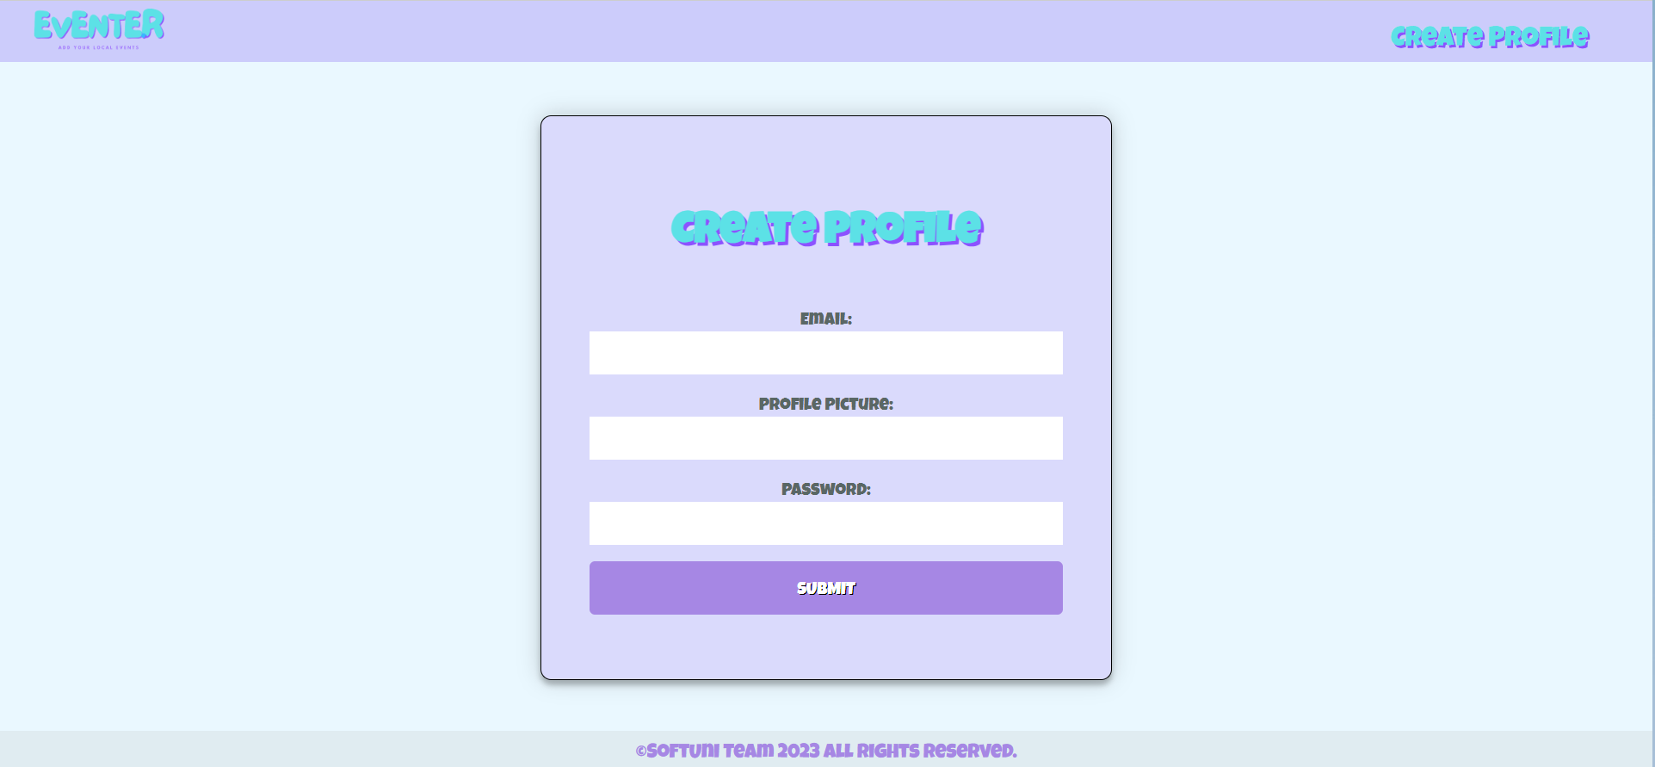

### Catalogue Page (10 pts)

**Template file**: **"events/dashboard.html"**

The **Dashboard Page** showcases **all the events created by the user**. However, in the **absence** **of any created events**, only the paragraph **"There are no Events in the Dashboard!"** will be visible.

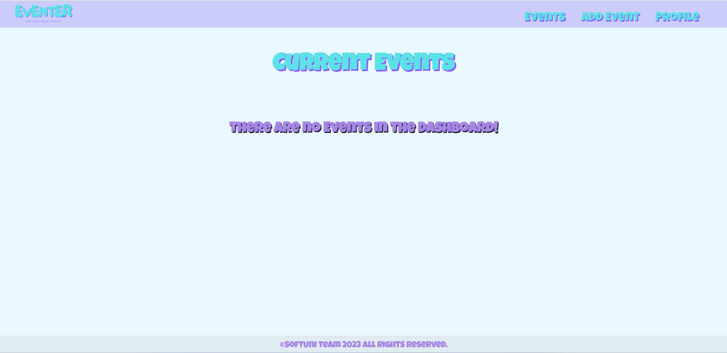

When both a **profile and event/s** are present, the page should display the following elements:

* A headline: **"Current Events"**
* For each event, a card-box should be presented, containing the event's **image**, **name** and **date**. Each card-box should also include a **"Details"** button, leading to the **Event Details Page** for the **selected event**

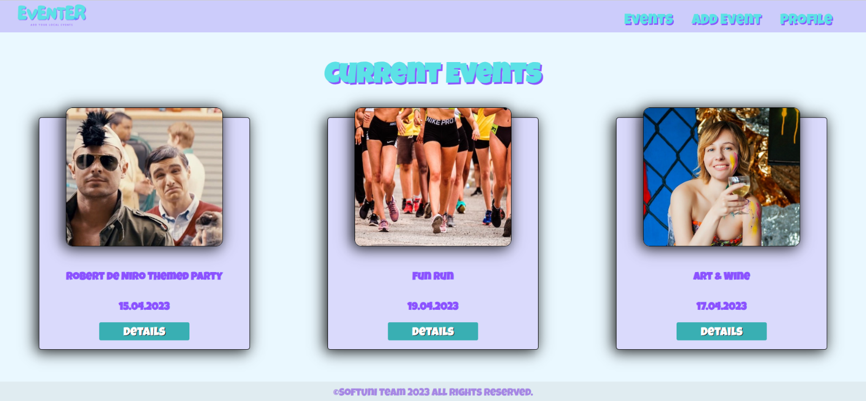

### Create Event Page (10 pts)

**Template file:** **"events/events-create.html"**

The **Create Event Form** consists of the following fields:

* **"Name:"** field
* **"Category:"** field
* **"Description:"** field
* **"Date:"** field
* **"Event Image"** field
* **"Create"** button

If the event is **successfully created**, clicking the **"Create"** button will redirect you to the **dashboard page**. In case of any incorrectly entered data, the form will display the relevant **error messages**.

* To ensure that the date field in your application adheres to the specified formats and deliver a consistent user experience when working with date values, kindly incorporate the following configurations into your **settings.py** file:

**DATE_INPUT_FORMATS = ["%d.%m.%Y"]**

**DATE_FORMAT = "d.m.Y"**

**USE_L10N = False**

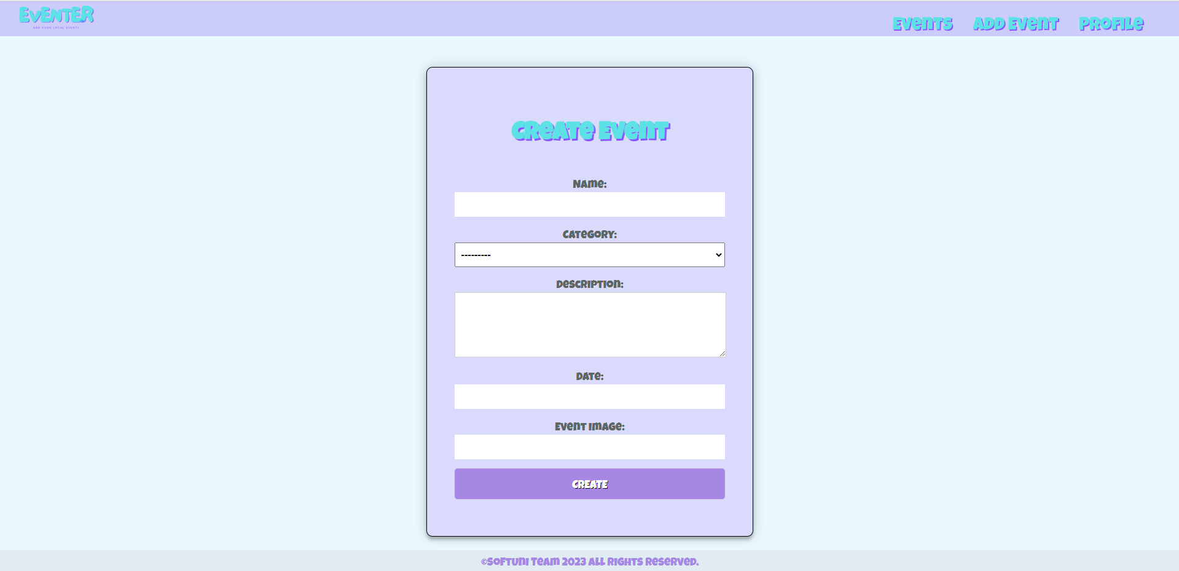

### Event Details Page (10 pts)

**Template file:** **"events/events-details.html"**

This page presents the data for the **selected event**. It should include the following components:

* A headline: **"Event Details"**
* A box containing the event's **image**, **name**, **category**, **date**, and **description**
* Action buttons:
  + An **"Edit"** button that directs to the **edit event page**
  + A **"Delete"** button that directs to the **delete event page**

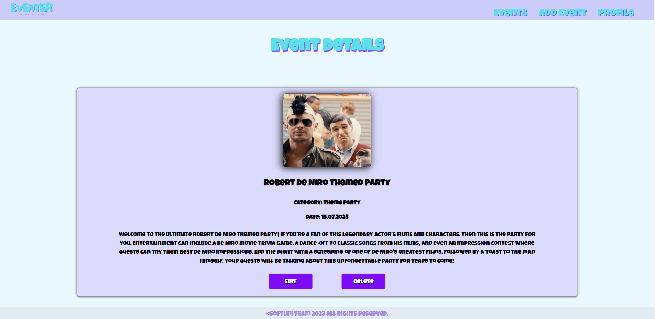

### Edit Event Page (10 pts)

**Template file:** **"events/event-edit.html"**

On the page, the form should be **populated** with the **data of the** **event that needs to be edited**.

When the **"Edit"** button is clicked:

* If the event is **successfully** edited, you will be redirected to the **dashboard page**
* Otherwise, the form will display the **relevant validation errors**

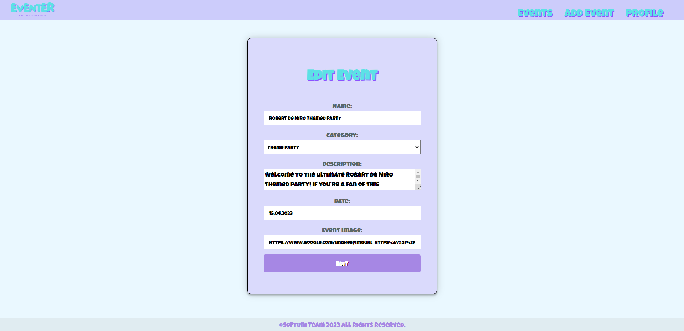

### Delete Event Page (10 pts)

**Template file:** **"events/events-delete.html"**

On the page, the form should be **populated with the data of the event**, and the fields should be **disabled**.

When the **"Delete"** button is clicked, the event will be **removed from the database**, and you will be redirected to the **dashboard page**. As a result, the deleted event will **no longer be visible** within the app.

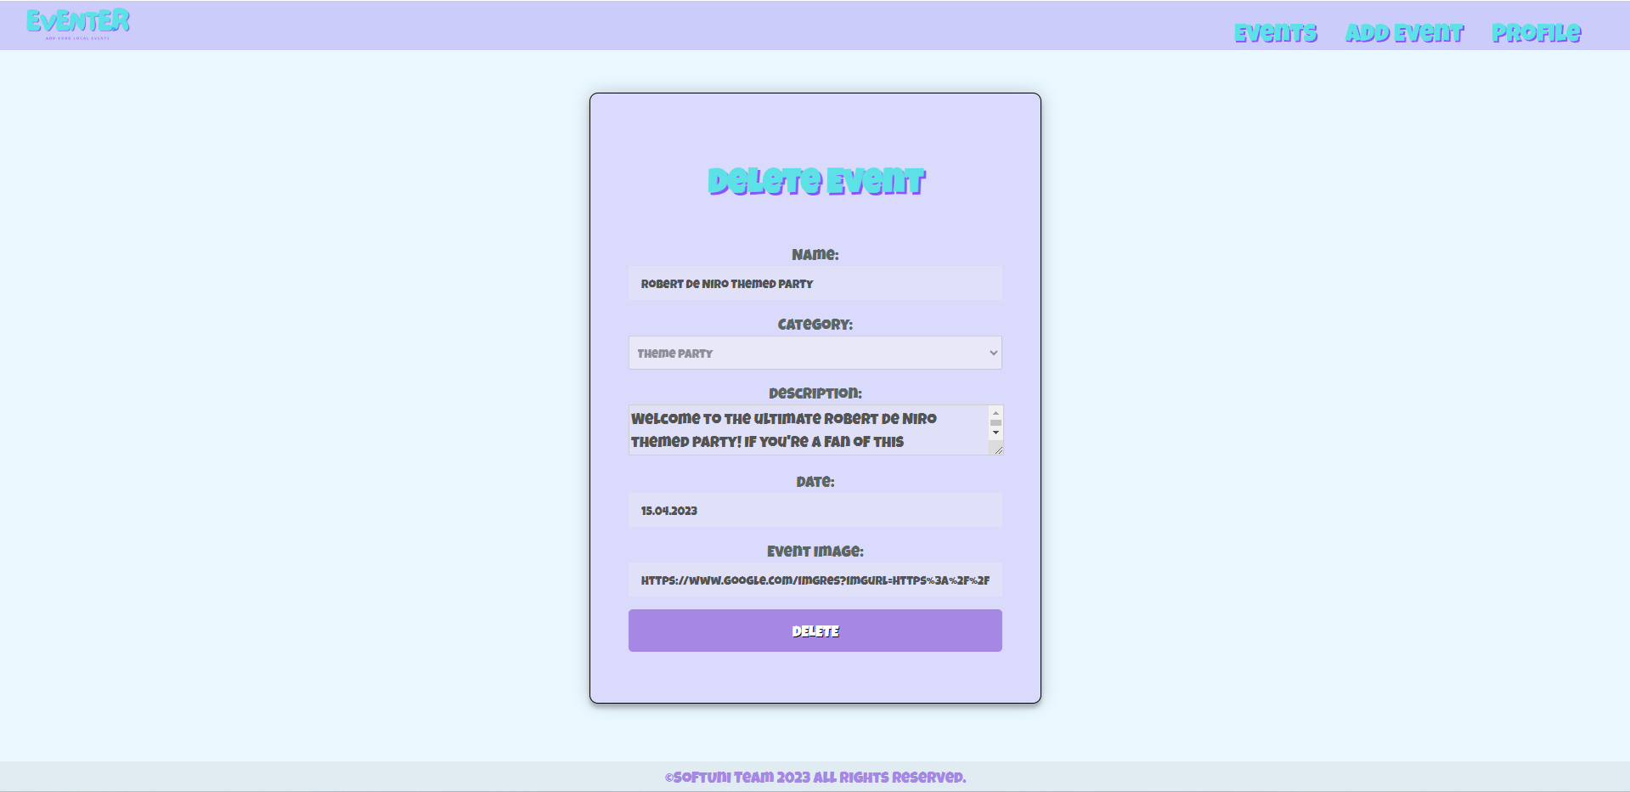

### Profile Details Page (10 pts)

**Template file:** **"profiles/profile-details.html"**

This page presents the **user's information** and comprises the following elements:

* A headline: **"Profile Details"**
* A **profile picture**. If no picture is provided, the page will display a **default profile picture** (located in the **static/images** folder)
* The **"Name:"** of the person (first and last name)
* **"Email:"** address
* **"Created Events:" total number** of events created by the user
* Action buttons:
  + An **"Edit"** button that redirects to the **edit profile page**
  + A **"Delete"** button that redirects to the **delete profile page**

When the user has not updated his/her name, the **"Name:"** field will be empty, as depicted in the image below:

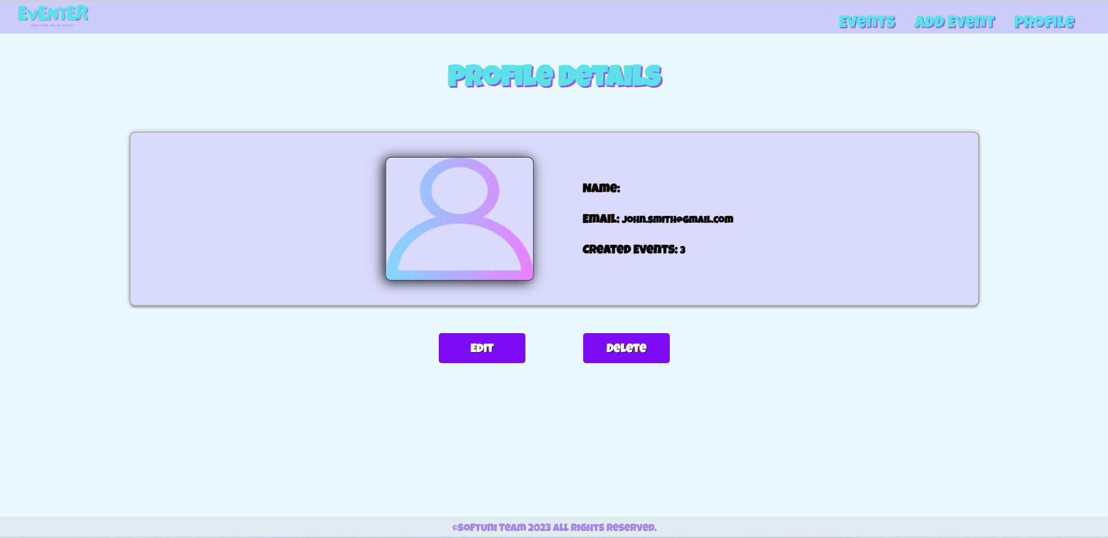

When the user provides his/her **"First Name"** and **"Last Name"**, they should be displayed in   
the **"Name"** paragraph:

### Edit Profile Page (10 pts)

**Template file:** **"profiles/profile-edit.html"**

On the page, the form should be **filled with the information of the profile** that needs to be edited. The **Profile Edit Form** includes **additional fields** as indicated below:

* A **"First Name:"** field
* A **"Last Name:"** field
* An **"Email:"** field
* A **"Profile Picture:"** field
* A **"Password:"** field

Upon clicking the **"Edit"** button:

* If the profile is **successfully edited**, you will be redirected to the **Profile Details Page**
* Otherwise, the form will display the relevant **validation errors**

* Note: Highly recommend finding a suitable widget that enables you to mask the password input using asterisk placeholders. However, please note that the visibility of the password, whether hidden or not, will not affect the evaluation or scoring of your exam. So, feel free to choose the approach that works best for you. The important factor is to ensure the functionality of the password input, rather than the visual presentation.

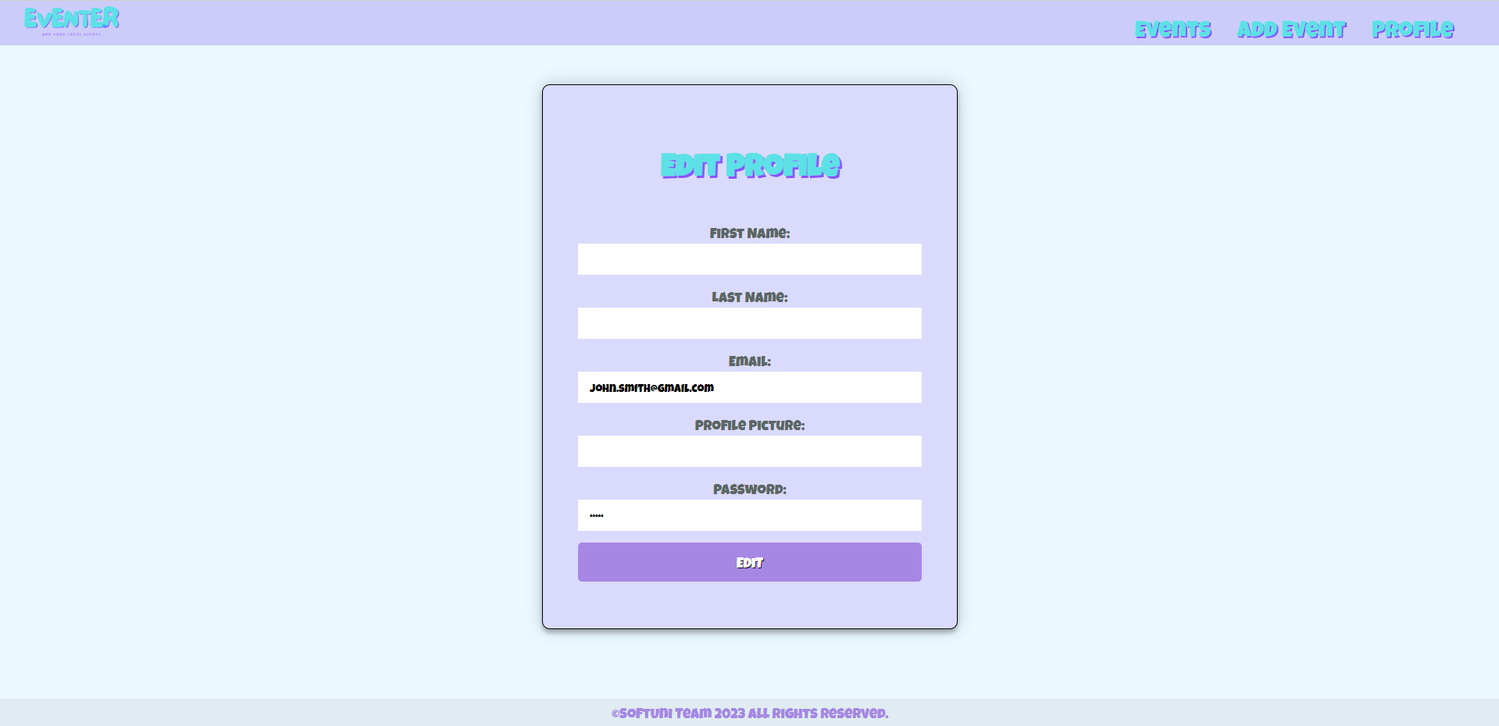

### Delete Profile Page (10 pts)

**Template file:** **"profiles/profile-delete.html"**

When a profile is deleted, it should **remove the profile information** as well as **all the events added by the user**. After the deletion, the user will be redirected to the **Home Page without a profile**: A screenshot of a computer
